**LAB # 07**

**Task # 01: Consume all web services:**

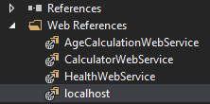

**Here localhost web service is AddtoCart web service**

**I am consuming web services by using webforms with master page**

**Solution:**

**Site1.master Design:**



**Calculator.aspx design:**

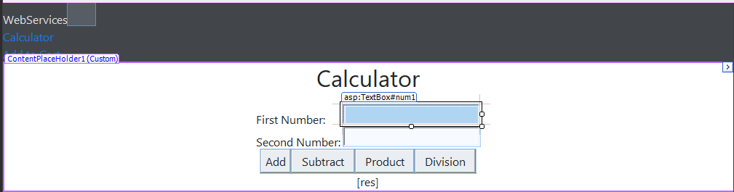

**Calculator.aspx.cs:**

public partial class Calculator : System.Web.UI.Page

{

CalculatorWebService.Calculator calculator = new CalculatorWebService.Calculator();

protected void Page_Load(object sender, EventArgs e)

{ }

protected void Button1_Click(object sender, EventArgs e)

{ double a = double.Parse(num1.Text);

double b = double.Parse(num2.Text);

res.Text = "Result: " + calculator.Add(a, b).ToString();

num1.Text = ""; num2.Text = ""; }

protected void Button2_Click(object sender, EventArgs e)

{ double a = double.Parse(num1.Text); double b = double.Parse(num2.Text);

res.Text = "Result: "+calculator.Subtract(a, b).ToString(); num1.Text = ""; num2.Text = ""; }

protected void Button3_Click(object sender, EventArgs e)

{ double a = double.Parse(num1.Text);double b = double.Parse(num2.Text);

res.Text = "Result: " + calculator.Multiply(a, b).ToString();

num1.Text = "";

num2.Text = "";

}

protected void Button4_Click(object sender, EventArgs e)

{

double a = double.Parse(num1.Text);

double b = double.Parse(num2.Text);

res.Text = "Result: " + calculator.Divide(a, b).ToString();

num1.Text = "";

num2.Text = "";

}

}

**Cart.aspx design:**

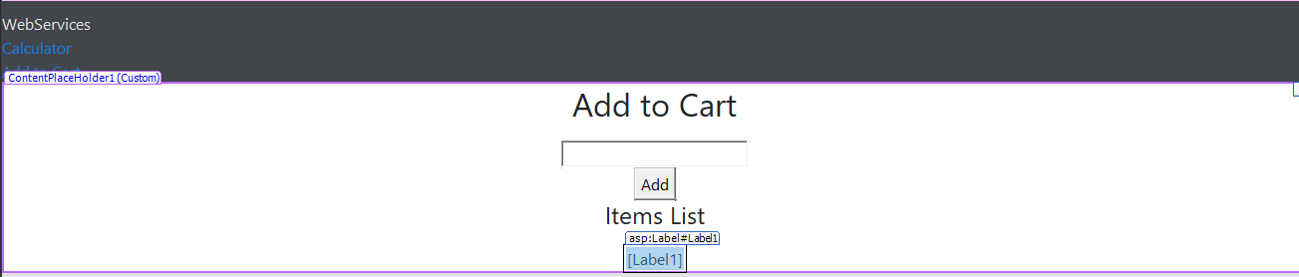

**Cart.aspx.cs:**

public partial class Cart : System.Web.UI.Page

{

protected void Page_Load(object sender, EventArgs e)

{ }

protected void btnAddItem_Click(object sender, EventArgs e)

{

localhost.AddtoCart client = new localhost.AddtoCart();

string itemName = txtItemName.Text;

string newItem = client.AddToCart(itemName);

List<string> cartItems = new List<string>();

if (Session["CartItems"] != null)

{

cartItems = (List<string>)Session["CartItems"];

}

cartItems.Add(newItem);

Session["CartItems"] = cartItems;

Label1.Text = string.Join("<br />", cartItems);

txtItemName.Text = ""; } }

**Output:**

